**The Viability of Fracking or To Frack or Not To Frack**

Teddy Dubno

May 9, 2016 Version 2.0

**1.Introduction**

Crude oil is one of the world’s most used resources. Oil and its distillates are employed in almost every sector of the modern world. Crude oil is used to fabricate plastic, distilled to make gasoline and diesel fuel used by modern transportation vehicles, and is heavily consumed in generators to create energy. With such widespread use in nearly all aspects of modern life, crude oil is a heavily traded resource with dramatic effect on the global economy. It is no surprise that one of the most heavily funded and researched areas in the search for energy is devoted to discovery and extraction of oil and other forms of fuel from the ground. This influx of capital allows for newer and better ways developing and perfecting oil extraction. With so much time, energy, and money being funneled into petroleum (another term for crude oil) there are new methods being developed and implemented that drastically amplify the production of oil. One of the most significant modern developments of oil and the related extraction of gas has been “Hydro Fracking.” The development of hydraulic fracking has had many dramatic global effects: from a radical shift in the price of oil to changing the rate of seismic activity. The pollution and other environmental effects resulting from this new extraction technique calls into question the viability of hydraulic shale fracturing as an energy extraction method.

**2. What is Fracking?**

**2.1 History of Fracking**

The physical geological fracturing of shale stone commonly referred to as “Fracking,” “Hydro Fracking,” or “Shale Fracking” is the process of removing petroleum and other

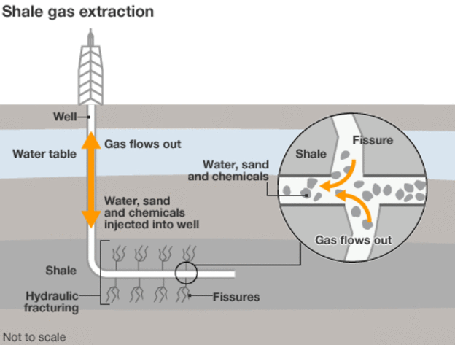

Figure 1 Simplified Graphic of Fracking Process1

natural gasses that are trapped in stone formations deep underground[1]. Some form of releasing trapped oil from stone has been under continuous development since the 1860s where nitroglycerin was used to shatter stones releasing the oil inside[2]. Towards the end of the 20th Century, pressured by relative high prices and foreign sources of crude oil, geologists developed far more useful and economical methods of petroleum extraction2. Modern day hydro fracturing, in which fracking solution is injected deep into shale deposits, has become a mature process (a simplification of which can be seen in Figure 1.)

The development of horizontal fracturing allowed for the shale stone to be more

efficiently extracted2. Hydro fracking is now used globally, with many countries beginning to explore fracking options[3].

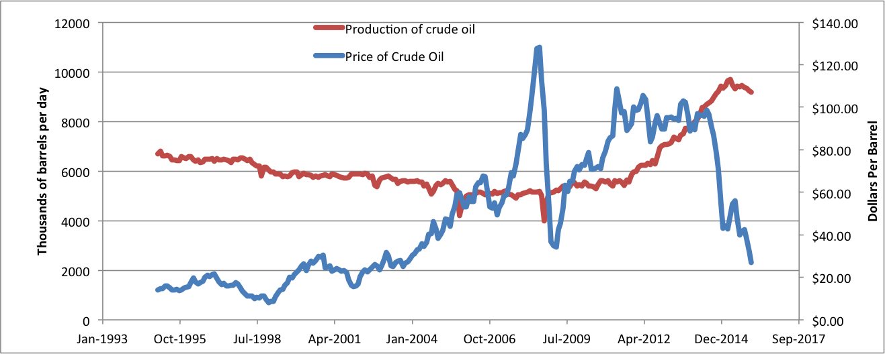

Figure 2 Price and production of crude oil5,6

The United States leads this boom, which has allowed geologists and oil producers to drastically increase gas production[4]. Fracking has been under development for many years with varying amounts of controversy and success2,[5]. As of late, fracking production has gone through a dramatic increase as visible in Figure 2. This increase in production has had a dramatic downward effect on the price of crude oil.

**3. Economic Effects of Fracking**

**3.1 Immediate Economic Effect of Fracking**:

Over the past two years there has been a significant fall in the price of oil[6] as seen in Figure 2. Current oil prices are generally perceived as an effect of increased supply caused by drastically higher production from crude oil pumped from wells in oil-producing countries11. This increased production is due to many varying political and economic factors. A major component of the increase in the availability of natural gas, a relative of petroleum, is related to hydro fracking. Using EIA estimates from 2013[7] reveals that shale gas fracking has become a major source of oil-related production in the United States. Not only is the market share of natural gas produced by fracking increasing but the net production as a whole is increasing as well.

This increase in estimated production ties in closely with the more recent statistics of oil production and further relates to production and oil prices. The increase in production caused by the development and implementation of shale fracking creates a clear supply/demand imbalance and highlights reasons for the severe decrease in price per barrel of late[8]. This imbalance is visible in Figure 3 of the supply/demand of recent quartly data. It is a simple supply and demand issue: As the supply of an object increases faster than demand can keep up with it then the price of that object will tend to fall mirroring this imbalance[9]. Using this basic relationship, it is much easier to see how this drastic increase in production of the United States from fracking is causing the visible drop in oil prices.

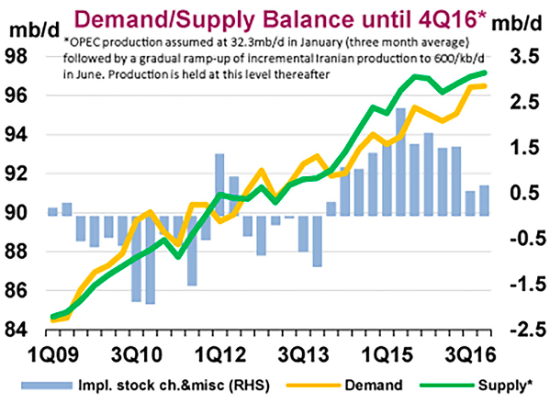

Figure 3 Supply & Demand Balance11

**3.2 The Economic Effect of Fracking on Non-US fuel producers**:

While the immediate effect of the United States’ production increases and the subsequent supply/demand imbalance may be straight forward, more subtle effects of fracking on the price of oil comes from other world oil producing areas. One of the most significant effects of the United States’ ramped up production as a result of fracking is the forced competition it has instilled in many of the nations that belong to OPEC (Organization of the Petroleum Exporting Countries[10])[11]. Due to increased production and subsequent dramatic increase in oil and oil derivative exports by the United States[12], OPEC has had to raise production to maintain market share on their exports as profits decline. Countries like Saudi Arabia, the largest producer and semi-leader of OPEC8, have the majority of their wealth coming from oil exports. In order to stay in the “race” and keep a competitive position relative to the United States, OPEC has had to increase production way beyond what is necessary to meet global demand. This intentional increase of production has caused the price of crude oil to plummet rapidly and has stabilized at historically low levels. OPEC oil producing powers have created a vicious cycle where production has to be increased to stay competitive yet as prices fall more needs to be produced and exported to insure profits remain flowing.

While this line of thinking is generally accepted as the source of the current economic situation, some believe increased production by OPEC, most notably Saudi Arabia, is due to the Saudis desire to eliminate economic and political competition[13]. Some analysts associate the current oil price situation with Saudi intent to control market share by lowering oil prices to destabilize political foes, like Iran, and to stunt the growth of US fracking technology.13. However, as evident by continued increases in shale oil production, OPEC’s ramped up production will probably not ultimately succeed in stopping increased and maturing shale oil production in the United States.

**3.3 The Cost of Fracking**

Fracking is a relatively expensive process involving the constant expansion of research and exploration, and its associated high maintenance costs[14]. The varying break-even cost per barrel varies from operation to operation14. The usual break-even price for United States fracking operation is somewhere between twenty five to fifty dollars with a few exceptions on either side14. As of the recent dramatic decrease in oil prices, many fracking operations have ended up below the break-even point. These break-even points have been calculated independently of the environmental costs so even without many of those factors many fracking operations may be operating at a net loss in the long-term.

**4. Environmental Effects**

A major focal point of the current fracking debate concerns the effect that fracking has on the local and global environment. There are three main areas of environmental concern that are in the center of attention for fracking viability. They are the occurrence of fracking-induced earthquakes, the pollution associated with fracking fluid, and the climate effects of methane emissions from the fracking process.

**4.1** **Induced Earthquakes**

One of the most significant and easily visible effects of fracking on the local environment is a dramatic increase in earthquakes that seem to appear relatively soon after the implementation of local large-scale fracking[15]. There are many theories as to the source of this increase in earthquakes, but almost all of the facts point to hydraulic extraction fluid, a chemical solution used in the fracking process[16]. These injection-induced earthquakes have led to some serious changes in the natural seismic conditions of the areas in which large scale fracking is taking place[17]. In the Central and Eastern United States, the frequency of magnitude three and greater earthquakes rose from an average of twenty one to approximately 659 earthquakes per year in just over six years; over a 2000% increase15! Earthquakes are becoming so significant that they can be felt by humans with no seismograph equipment and have been empirically determined to be a direct result of the fracking process17. Fracking is responsible for these earthquakes due to the nature of the hydraulic injection fluid and the proximity to the natural pre-existing fault lines16. As the hydraulic fluid is pumped underground to release the shale gas deposits, the corrosive solution irritates the natural faults and causes increased seismic interaction 17. As of now the magnitude of these earthquakes have been on the low to mild range with the majority being sub three on the magnitude scale, however as fracking increases in magnitude so does the magnitude of the earthquakes with the more recent earthquakes being so easily detected that they can be noticed by the general population17. The dramatic increase in earthquakes as likely caused by fracking is just one of the ways in which large-scale fracking affects the local environment.

**4.2 Water Pollution**

One of the other major local environmental impacts of fracking is the water pollution that can occur with the mistreatment of reclaimed hydraulic fracking solution.[18] There are two major water pollution problems that can be a result of the fracking process, surface water contamination and fumes from the recaptured ground water[19]. When the fracking fluid is collected after use, it is often collected in condensation tanks. These tanks are sometimes not airtight and can release harmful chemicals into the atmosphere19. These gaseous chemicals can have a dramatic effect on the health of nearby residences19. Chemicals detected include Diesel fumes, Hydrogen sulfide, Formaldehyde, radioactive substances as well as others, which have not been identified yet19.

In addition to harmful and potentially poisonous fumes there have been many reports that improperly managed fracking solutions have made their way into the local water supply[20]. This has led to certain drinking sources becoming so contaminated that a small flame can ignite them20. One of the many examples of this is visible in Figure 4 where an Australian river near fracking operation easily combusts with a small source of ignition. 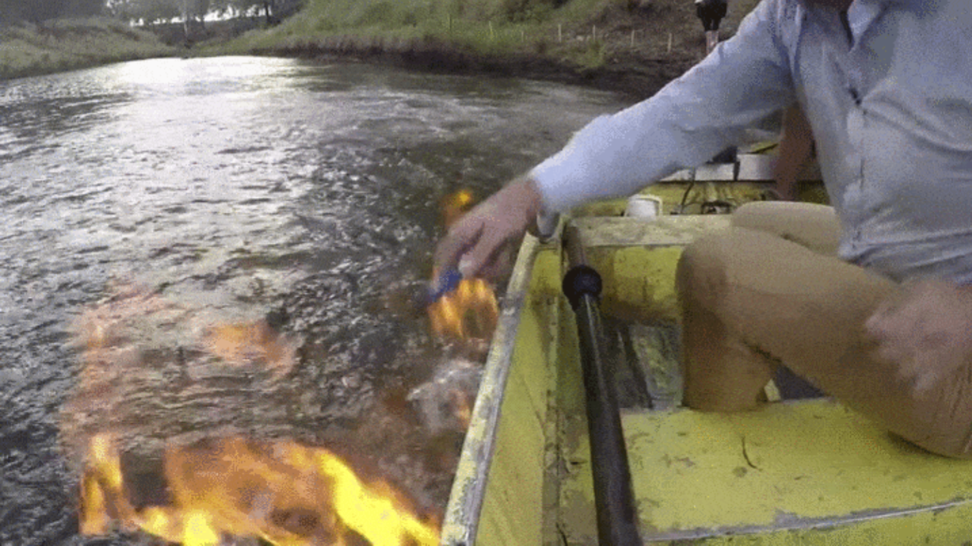 On the local level, these contaminants drastically affect the health of anyone who happens to be nearby and dramatically effect the surrounding environment.

Figure 4 Ignition of River Water Near Fracking Operation20

**4.3 Methane Pollution**

The largest effect of the fracking boom is the increased release of methane into the atmosphere. Methane is an incredibly potent greenhouse gas: it can be twenty-two times as effective at storing heat as the same amount of carbon dioxide25. Fracking has led to a dramatic increase in the release of methane into the atmosphere with many estimates have fracking releasing 1.5 times as much methane into the atmosphere as normal natural gas extraction25. This immediate effect of methane in the atmosphere is not as easily visible as the earthquakes or the water pollution however it may have far more drastic environmental consequences25. The greenhouse effect that is mainly responsible for climate change will be one of the biggest hurdles facing future generations and using an energy extraction method that only exacerbates green-house gas emissions will either make the environmental problem worse or put pressure on legislators to halt fracking methods.

**4.4 Loss of Water**

Another less easily visible side effect of fracking is the technique uses a lot of water and as much as 90% of that water is unrecoverable with current extraction methods[21]. As of now, oil and natural gas are more expensive and “valuable” than potable drinking water, however many future projections estimate that water could emerge as the chief and most desired commodity of the future as it is essential for life[22]. With global droughts on the upswing and water becoming more and more precious, using millions of gallons of water per day[23] becomes more and more impractical and environmentally unsustainable.

**4.5 Potential offsetting**

One way that an environmental cost can be put on fracking currently is environmental offsetting. As there are many estimates as to the average methane released per year, per site, per barrel and they all vary greatly[24],[25], it is far easier to use the more common CO2 offsetting as a base line environmental cost. Using pretty liberal estimates and not even accounting for the release in methane, the cost to offset the CO2 emissions from fracking would appear to be astronomical. Using EPA estimates .43 metric tons of CO2 are released per barrel of Oil produced by fracking24 and IEA estimates 9179 thousand barrels of oil are produced per day it follows that:

There are 394697 tons of CO2 emitted per day as a result of mostly fracking in the United States. At the current price to offset a ton of CO2, which is approximately ten dollars[26], it comes out to $3946970 per day. The cost to produce a barrel of oil would increase by $4.3. This may not appear to be significant, but this offset is only to compensate for the less harmful CO2 emissions, and with the price of oil fluctuating at its current rate four dollars may be more than enough to make fracking unprofitable.

**5. Conclusion**

Fracking is occurring on a global scale and the effects of this are just beginning to be shown. As fracking becomes the dominant form of oil and natural gas production in the United States and controls a larger market share globally the effects of fracking will be more easily observable on a much wider scale. While fracking has a significant effect on the local environment and the global economy, its impact is not as well established or researched as the practiced old methods of oil and traditional natural gas extraction. With any new technology and practice, assessing the viability of such a practice must be analyzed and reviewed. In this way, the long-term effects of continued and expanding fracking are only now being researched and beginning to be understood. Hydraulic fracking is an incredibly environmentally and economically caustic process, which affects millions of people in both the local and global scale. It has been responsible for creating a large number of jobs while radically lowering the price of oil. Fracking has a significant effect on the environment whether it is a source of more frequent earthquakes, polluting potable water, or releasing an ever-worsening quantity of greenhouse gasses. Meanwhile the long-term cost to produce a barrel of oil is far too close to the price that it sells for. All in all, hydraulic shale fracturing, or fracking’s viability as a current or future reliable fuel extraction method is on shaky ground. Regardless of the objective lack viability, fracking will likely continue to be a major fuel extraction source for the foreseeable future despite this being one of the most contested and lobbied issues at the moment[27]. However, there are people fighting against fracking and many have recognized evidence of fracking’s effect on the planet. Environmentalists are suing government agencies responsible for not intervening[28] Fracking, as it currently stands, may not be the worst thing in the world as there are some positives to fracking and getting easier access to crude oil is only one of them. , However, with the current lack of regulation or tepid governmental intervention, fracking, as it now stands, is in no way a viable long-term method of oil and natural gas extraction.

[Word Count: 3150]

1. "What Is Fracking and Why Is It Controversial? - BBC News." BBC News. Accessed May 06, 2016. http://www.bbc.com/news/uk-14432401.
2. Montgomery, Carl T., and Michael B. Smith. "Hydraulic Fracturing: History Of An Enduring Technology." *Journal of Petroleum Technology* 62, no. 12 (2010): 26-40. Accessed May 5, 2016. Doi: 10.2118/1210-0026-jpt.
3. Wasley, Andrew. "On the Frontline of Poland's Fracking Rush." The Guardian. 2013. Accessed May 06, 2016. http://www.theguardian.com/environment/2013/mar/01/frontline-poland-fracking-frontier.
4. Conca, James. "U.S. Winning Oil War Against Saudi Arabia." Forbes. Accessed May 06, 2016. http://www.forbes.com/sites/jamesconca/2015/07/22/u-s-winning-oil-war-against-saudi-arabia/#4872e19e7876.
5. "Crude Oil Production." Crude Oil Production. Accessed May 06, 2016. https://www.eia.gov/dnav/pet/pet_crd_crpdn_adc_mbblpd_m.htm.
6. "U.S. Crude Oil First Purchase Price." EIA. Accessed May 5, 2016. https://www.eia.gov/dnav/pet/hist/LeafHandler.ashx?n=pet&s=f000000__3&f=m.
7. "U.S. Energy Information Administration - EIA - Independent Statistics and Analysis." EIA's Energy in Brief: What Is the Role of Coal in the United States? Accessed May 06, 2016. https://www.eia.gov/energy_in_brief/.
8. "Commodities: Latest Crude Oil Price & Chart." NASDAQ.com. Accessed May 06, 2016. http://www.nasdaq.com/markets/crude-oil.aspx.
9. "Economics Basics: Supply and Demand | Investopedia." Investopedia. 2003. Accessed May 06, 2016. http://www.investopedia.com/university/economics/economics3.asp.
10. "Home." OPEC:. Accessed May 06, 2016. http://www.opec.org/.
11. "Why Crude Oil Prices Keep Falling and Falling, in One Simple Chart." Vox. 2016. Accessed May 06, 2016. http://www.vox.com/2016/1/12/10755754/crude-oil-prices-falling.
12. "U.S. Exports of Crude Oil and Petroleum Products." U.S. Exports of Crude Oil and Petroleum Products. Accessed May 06, 2016. https://www.eia.gov/dnav/pet/pet_move_exp_dc_NUS-Z00_mbblpd_m.htm.
13. "Welcome to Market Realist." Crude Oil's Total Cost of Production Impacts Major Oil Producers. Accessed May 06, 2016. http://marketrealist.com/2016/01/crude-oils-total-cost-production-impacts-major-oil-producers/.
14. Randall, Tom. "Break-Even Points for U.S. Shale Oil." Bloomberg.com. 2014. Accessed May 06, 2016. http://www.bloomberg.com/news/2014-10-17/oil-is-cheap-but-not-so-cheap-that-americans-won-t-profit-from-it.html.
15. "Induced Earthquakes." Induced Earthquakes. Accessed May 05, 2016. http://earthquake.usgs.gov/research/induced/.
16. Ellsworth, W. L. "Injection-Induced Earthquakes." *Science* 341, no. 6142 (2013): 1225942. Accessed May 5, 2016. doi:10.1126/science.1225942.
17. Skoumal, Robert J., Michael R. Brudzinski, and Brian S. Currie. "Earthquakes Induced by Hydraulic Fracturing in Poland Township, Ohio." *Bulletin of the Seismological Society of America* 105, no. 1 (2015): 189-97. Accessed May 5, 2016. doi:10.1785/0120140168.
18. Kalyani Robbins, *Awakening the Slumbering Giant: How Horizontal Drilling Technology Brought the Endangered Species Act to Bear*, 63 Cas. W. Res. L. Rev. 1143 (2013)   
    Available at: http://scholarlycommons.law.case.edu/caselrev/vol63/iss4/8
19. Srebotnjak, Tanja, and Miriam Rotkin-Ellman. "Fracking Fumes: Air Pollution from Hydraulic Fracturing Threatens Public Health and Communities." (2014).
20. Limer, Eric. "This River Near a Fracking Site Is Alarmingly Flammable." Popular Mechanics. April 26, 2016. Accessed May 05, 2016. http://www.popularmechanics.com/technology/a20553/australian-river-on-fire-fracking/.
21. "EARTHWORKS | New Fracking Report Finds High Levels of Water Consumption and Waste Generation." EARTHWORKS | New Fracking Report Finds High Levels of Water Consumption and Waste Generation. October 30, 2103. Accessed May 05, 2016. https://www.earthworksaction.org/media/detail/new_fracking_report_finds_high_levels_of_water_consumption_and_waste_genera#.VyvUpaMrKRs.
22. Domm, Patti. "This Is the Hottest Commodity of the Future." CNBC. July 02, 2014. Accessed May 05, 2016. http://www.cnbc.com/2014/07/02/why-trading-water-futures-could-be-in-our-future.html.
23. "USGS FAQs." - Hydraulic Fracturing ("Fracking"). Accessed May 05, 2016. http://www2.usgs.gov/faq/categories/10132/3824.
24. "Climate and Fracking - CAFrackFacts." CAFrackFacts. Accessed May 05, 2016. http://www.cafrackfacts.org/impacts/climate/#fnref-159-5.
25. Howarth, Robert W. "Methane emissions and climatic warming risk from hydraulic fracturing and shale gas development: implications for policy."*Energy and Emissions Control Technologies* (2015): 46.
26. Gies, Erica. "A Guide to Offsetting Your Carbon Emissions." Grist. October 11, 2006. Accessed May 05, 2016. https://grist.org/article/gies2/.
27. Richardson, Valerie. "Fracking Politics Trump Science as Oil Industry, Environmental Lobby Push Biased Views." Washington Times. Accessed May 05, 2016. http://www.washingtontimes.com/news/2015/apr/28/fracking-politics-trump-science-as-oil-industry-en/?page=all.
28. Goldenberg, Suzanne. "Fracking: Environmental Groups Sue EPA in Call for Strict Rules on Waste." The Guardian. 2016. Accessed May 05, 2016. http://www.theguardian.com/environment/2016/may/04/epa-fracking-lawsuit-environment?utm_source=Daily Carbon Briefing.